A University-wide System for Creating, Capturing,

and Delivering Learning Objects

Joseph B. South David W. Monson
Brigham Young University Brigham Young University
Center for Instructional Design Center for Instructional Design
3800 HBLL 3800 HBLL
Provo, UT 84602 Provo, UT 84602
801/378-9382 801/378-8338
FAX: 801/378-8910 FAX: 801/378-8910
Joseph_South@byu.edu David_Monson@byu.edu

Running Head: University-wide System
A University-wide System for Creating, Capturing, and Delivering Learning Objects

For organizations to take full advantage of the potential benefits of learning objects, learning objects must become an integrated part of the instructional technology infrastructure. At Brigham Young University in Provo, Utah, a coordinated effort, including our division of continuing education and our library, is underway across the university to create a unified system for developing, capturing, and delivering learning objects to both on and off-campus venues. This chapter will describe the theoretical framework we use to conceptualize and work with learning objects, the core issues that led to this effort, the principles that guide our approach, the solution that we are working toward, the particular role of learning objects in that solution, as well as the benefits that we anticipate as a result. The goal of the chapter is to provide a sense of the far-reaching impacts of our decision to use digital learning objects at the core of our instructional technology systems, including some of the obstacles that must be overcome and the tradeoffs that are required.
Theoretical Framework

Definition of Learning Object
We define “learning objects” as digital media that is designed and/or used for instructional purposes. These objects range from maps and charts to video demonstrations and interactive simulations. Because of this wide range of sophistication, we use the more conservative term “media objects” when describing these objects at our university. However, the types of objects we are creating and using fall within the definition of “learning objects” given by David Wiley in the introductory chapter in this book. We presently produce all of the types identified in Wiley’s (2000) taxonomy except the fifth type identified, the “instructional-generative,” but hope to begin producing this type in the near future.

Learning Objects and the “-ilities”
Various lists of “ilities” are often invoked within the working groups of the Advanced Distributed Learning Network (ADLNet), IMS, and IEEE LTSC P1484.12, organizations working on learning object specifications and standards. These lists generally include durability, interoperability, accessibility, reusability, discoverability, extensibility, affordability, and manageability. The central benefit of learning objects upon which most institutions focus, including our own, is their potential for reuse. Generally, the most expensive elements of instruction to produce are the media intensive assets. If these assets could be reused, the argument goes, production costs could be greatly reduced. This, in theory, provides the primary financial rationale that justifies investment in the infrastructure required to realize a learning object centered system. It is our experience that the degree to which learning objects actually achieve high reusability is largely a function of the degree of granularity of the objects. That is, the more granular the object, the more reusable it becomes (see Wiley, et al., 1999, for a theoretical discussion of this relationship).

Choosing the Right Level of Granularity
Determining the degree of granularity of what should constitute a learning object is a foundational decision for any project. There is not necessarily a correct level of granularity. Certainly, it is essential to consider courses, lessons, and modules as learning objects. But these levels do not cross what we call the “context threshold” (See Figure 1.). In other words, until you get past this level of granularity, the majority of your costly media assets are trapped in the surrounding context – too intertwined in the material that precedes and follows to be efficiently extracted and reused by instructional developers.
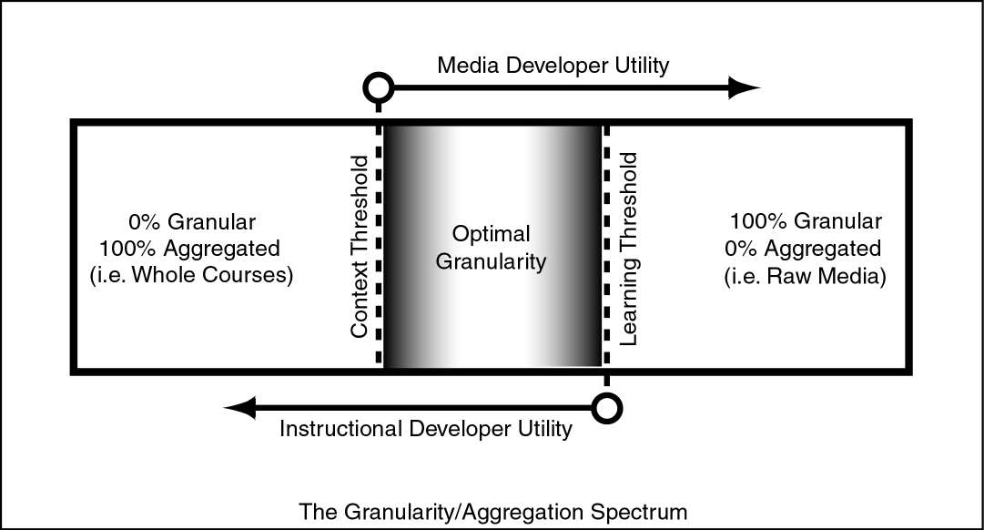
Figure 1. Granularity/Aggregation Continuum.
Obviously, a total lack of context would reduce the learning object to unassociated media (e.g. a background image, a sound file, a movable foreground element, etc.). While still of potential use to a media developer, it begins to lose its immediate usefulness to an instructional developer. At some point, the object crosses what we call the “learning threshold” – it no longer retains enough internal structure to be recognizably oriented to a learning purpose and loses its embedded instructional utility.
The optimal level of granularity must be determined for each project based on its individual goals. From the perspective of instructional developers, our experience is that it is most useful to move from the course level of granularity down to the concept level when designing, but not so far down as the individual media asset level. For our instructional needs, objects have the greatest potential for reuse when they center on a single, core concept. At this level, they can easily slip into another context while still retaining significant instructional utility. For example, an interactive simulation that allows a learner to manipulate a pressure gauge, the shape of a container of liquid in which it is submerged, and the depth of that liquid is what we would consider a concept level media object (See Figure 2). It is granular enough to be useful in a variety of contexts, but aggregated enough to provide a robust exploration of multiple facets of a single concept.
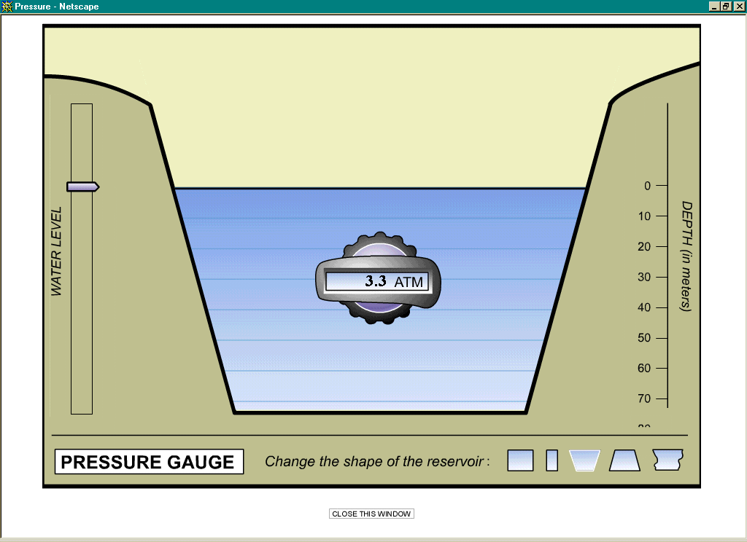
Figure 2. Pressure gauge simulation. Container shape, water level, and gauge can be manipulated to observe the resulting affect on pressure gauge reading.

The Metadata Tradeoff
Unfortunately, this greater level of granularity comes with at least two significant tradeoffs. The first is that you must provide a proportionately greater amount of metadata to retain high discoverability, that is, make it easy for instructional developers, instructors and learners to find the objects in a vast database that match their needs. The second trade off is that you must store and manage significantly higher numbers of objects. For example, a recently developed physical science online course, while consisting of only 34 lessons and approximately 350 web pages, contains over 1300 media objects, ranging from simulations like the example given above to charts and diagrams that could arguably be considered more informational than instructional, but still of use to instructional developers. In the past year, we have produced more than 5,000 media objects that need to be associated with metadata to be reused in instructional contexts.
When tracking so many objects, the cost of creating high quality metadata for each object as well as the cost of storing and managing them becomes a significant issue. We will discuss our approach to this challenge later in this chapter.
As significant and complex as these issues are, the use of learning objects allows us to address systemic barriers to the long-term growth and viability of our institution. A discussion of these barriers follows.

The Challenge
Brigham Young University is a large regional university, owned and operated by the Church of Jesus Christ of Latter-day Saints (LDS Church), which serves an on-campus population of over 30,000 students as well as over 40,000 off-campus independent study students. Like many other institutions of higher education, BYU sees the potential for learning objects to address core cost, infrastructure, and quality issues related to instructional media. This potential has led BYU to invest early and significantly in a campus-wide system that is based on a learning objects approach to courseware design and delivery. This initiative has required close cooperation and coordination between the university’s Center for Instructional Design, the Office of Information Technology, the Lee Library, the Division of Continuing Education, and Independent Study. Cooperation on this scale was made possible by our shared understanding of university-wide challenges that need immediate attention. A summary of these challenges follows.

More Qualified Students than Seats
Each year, BYU turns away a number of students who meet our academic criteria, but for whom we have no space. Because most of these are also members of the LDS Church, we feel a particular obligation to accommodate their desire for higher education at our Church-owned University. Unfortunately, the cost of physical expansion of the university in terms of both capital investment and maintenance is high. With the present campus comprising 339 buildings on 200 acres of land, the university’s board of trustees has imposed a moratorium on physical expansion. Because of this limit, we need to find creative ways to provide a high quality university education to more students without physically expanding.

Growing Independent Study Program
At the same time, we are seeing sharp enrollment increases in both our paper-and-pencil and Internet-based Independent Study course offerings. Total enrollment is nearing 50,000 with about 10,000 online enrollments. This represents an expanding constituency of learners who desire high-quality, remotely accessible BYU courses. Presently, BYU’s on-campus enrollment can accommodate only 3 % of LDS men and women between the ages of 18 and 25. In 25 years, as the total number of LDS people in this age range is projected to swell to over 4.5 million, that percentage will drop to less than 1 percent.
This growth is further complicated by the fact that more than 70 % of these men and women will live outside of North America, far from Provo, Utah. If BYU wants to be available to any significant percentage of qualified students among the members of the LDS Church, distance education appears to be the most viable option. If we are to meet this demand, our off-campus distance education offerings will need to undergo significant expansion.

Multiple Learning Environments
As a partial solution to the expanding student base, BYU has begun to explore using online courses to accommodate more students both on- and off-campus. Consequently, we find ourselves facing at least three distinct instructional settings where effective use of technology to aid learning is desired (See Figure 3). These are 1) on-campus courses where media is used in classroom presentation, 2) hybrid courses where media may be used both during classroom sessions and in online sessions, and 3) independent study online courses where media supports the instruction of students who will never meet in a classroom. As technology continues to evolve, we anticipate more and more learning environment configurations, each with its own set of capabilities and constraints.

Multiple Learning Environments Using Instructional Media
Traditional Classroom | Hybrid Semester Online | Independent Study Online
Traditional on-campus classroom in which an instructor desires to draw upon learning resources that require the use of technology, usually as part of the instructor’s presentation of class material. | An on-campus online course that meets once a week or less, that must be completed within a single semester, and that conducts the majority of course work online. | An off-campus course conducted entirely online that must be completed within one year of the start date.

Figure 3. Multiple Learning Environments. We must insure that our approach to instructional media meets the needs of all of these environments.

Rising Development Costs
As the demand for digital media to support these three venues grows, our development costs grow with it. Digital media designers and programmers are in high demand and, therefore, difficult and expensive to hire on university wages. Additionally, research that we have conducted on students’ reactions to digital media shows face validity is a very real issue, and that they expect high production values in instructional media design, and that media that is perceived by students as “home-made” or “clunky” can significantly limit its instructional impact. This means that even simple objects can require several hours of expensive design and development by instructional and media professionals. We have also found that as media has converged to multimedia, production costs have risen in parallel with the increasing complexity.

Inefficient Delivery Methods
Yet even as these demands grow, a majority of the instructors on-campus rely on analog, non-networked technologies for their instructional media. An internal study of BYU faculty reveals that instructors tend to use the technologies they are most familiar with, and, for most of them, that means older, “off-line” technologies that require specialized and incompatible media formats and, therefore, specialized and incompatible media players. BYU employs an army of students that do nothing more than shuttle these players to and from classrooms all over campus. BYU maintains dozens of slide projectors, VCR’s (including VHS, one inch, and Beta formats), laser disc players, film projectors, CD players, tape players, record players, DVD players and computer projectors for the sole purpose of bringing them to a classroom at an instructor’s request. The system is cumbersome – requiring instructors to reserve the equipment well in advance – and requires many human resources. Further, the analog nature of most of the media often precludes learners from accessing the media outside of class due to the logistical complexity of making copies of it and its appropriate player available for them.

Inconsistent and Incompatible Formats
In addition to the incompatible physical formats mentioned above, we have instructors buying and/or producing instructional media in digital formats that are incompatible with each other. Some of the media works only in a single browser or under a single operating system, some requires a proprietary plug-in or codec or obscure streaming protocol; some demand continuous Internet access while others do not, but must instead be installed on each computer in each computer in a lab individually (BYU maintains over 600 computers in open labs).

Redundant Effort
Even if two departments happen to be using the same technology, and even the same content, resource sharing is not guaranteed. In fact, it is quite rare. We have found that one department, for example, an art history department, may have invested thousands of dollars in a slide library that has a 60% overlap with another department’s slide library, such as that of the history department or the design department, in which more thousands of dollars have been invested. While considerable expense could be avoided if the two were to invest in a single library, each is apprehensive about the other causing loss, damage, or simple unavailability of the individual slides at times that the other department might need them. This redundancy is compounded when the two departments fund separate media development projects that overlap in content.

Expensive, Low-impact Innovation
Even when instructional media development projects do not overlap, the projects can be problematic. Typically, their origin consists of a single faculty member from a single department coming up with a fabulous idea for using instructional media to improve a particular course. If that project is funded and developed, it is our experience that the resulting media is generally used exclusively by that faculty member. The media is often too specialized to the purposes of the originating faculty member be used by another faculty member, even if the two are teaching in the same subject area, unless they are teaching the same course. Further, the media is rarely customizable or easily adapted for other contexts. If it is not useful as a whole in its original form, it is not useful. As a result, large sums of money are spent on relatively low impact innovation. This can cause jealousies within a department as well as a general reluctance by university administration to fund innovation as each project appears to them to be a “pet project” of an individual faculty member.

Complex Media Management
The previous four problems can create a nightmare scenario for the management of a university’s media assets. If media is incompatible, inaccessible, and esoteric, and if each asset requires a different delivery method, it is very difficult for a user or manager to know 1) what assets exist, 2) where they reside, 3) what their physical condition is, 4) if they are useful for a particular context, 5) if the correct media player is available to display the desired media at the desired location, and 6) if the person who wants to use it will know how to work that player.

The cumulative effects of these problems can create an anti-media bias and an institution that views most instructional media as an expensive, clunky, irrelevant, impractical, inflexible, unfulfilled promise. Under the above circumstances, this view is probably correct.

The Approach
The range of possible solutions to the above problems is vast, extending far beyond our approach to instructional technology. While our approach to instructional technology alone cannot resolve all of the problems, it can have a significant impact on all of them. In determining what our approach would be, BYU established some core principles to guide our decisions.

Meet Present Needs While Anticipating Future Adaptation
Too often, institutions of higher education adopt an approach to instructional technology that benefits only the most technologically advanced. They may choose an approach that, in order to be successful, requires instructors and learners to come rapidly up to speed on complex technical tools. New and faster computers and sophisticated software is made available to faculty members who have the time and inclination to jump in, but their less technically adept – or simply overworked – colleagues are left wringing their hands in the shadows of the new faculty techno-stars. Anyone still teaching in a normal classroom with normal students is in danger of becoming disenfranchised and being characterized as “old school” and out-of-date.
Because of this danger, we felt strongly that any instructional technology solution we chose needed to reach into and improve the present, face-to-face teaching environment, without requiring extensive training for instructors and learners. To accomplish this, we established a policy that we would focus our energies on meeting present needs, while anticipating that, as the faculty become more comfortable with technology, they will want to adapt their teaching to take more and more advantage of a digital environment. Our goal was to create media that could be easily pulled in to a classroom, where an instructor might be using the traditional lecture format, while also making it available for use in an online lesson where the instructor may have left the physical classroom behind. In order to get the buy-in necessary for widespread utilization of digital instructional media, we felt it was important that faculty see immediate benefit, as well as long-term appeal, and that they feel like they could participate in using new technology without a lot of technical ability.

Leverage Innovation for Broad Audiences
A related goal was to make sure that if significant funds were to be allocated to instructional media development projects, the resulting media would be useful to many instructors and learners at the university. For example, it became part of our funding criteria that large projects have an instructional impact that would transcend departmental boundaries.

Streamline Design, Development, and Delivery
Because demand for instructional media is increasing rapidly all over the university, it was imperative that we ensure that the process of designing, developing, and delivering media become more efficient. A common source of inefficiency in this process at many institutions is the tendency for both university faculty and instructional designers to take an artisan approach to the development of instructional media. In this approach, the creator of the media works alone or perhaps with one other person. The instructional media is designed and developed with little outside feedback or technical expertise. The faculty member or designer is generally learning the technology as they create the media and focus their efforts on meeting only their needs. We felt we needed to streamline this process by bringing more technical expertise to bear and by implementing a more disciplined development process. We also wanted to be sure that these efficiencies weren’t lost in an unwieldy delivery system that introduced inefficiencies of its own.

Improve Quality
Finally, it was continually our focus to improve the quality of the instruction both in the classroom and online. A key feature of this was to involve an instructional designer in every university-funded project. This would increase the chances that instruction, rather than a particular favored technology, was in the driver’s seat. We also recognized that while many faculty members are excellent teachers and researchers, their background in areas such as interface design or Internet-based instruction is usually limited. Some models of development do little more than put relatively high-end development tools in the hands of the faculty member or their teaching assistants, leaving them the entire task of design and development. Rather than forcing them into a role to which they were not suited or trained, it was our goal to bring to them the support of instructional designers, graphic designers, illustrators, 3-D animators, media designers and programmers to create a product that was exemplary in content, instructional approach, visual design, and technical soundness.

Involve Students
Finally, as a university, we felt a strong commitment to integrating students into the process of developing instructional media. As a result, we organized the Center for Instructional Design in such a way that each area was overseen by professionals, but staffed by students. Our full-time instructional designers, artists, animators, audio/video producers, and programmers number less than 50 while the number of students working in those areas totals more than 150. This approach helps to keep wages down while providing invaluable practical experience for students seeking work in media-related fields.

The Solution
The title of this section may be a bit optimistic. The solution described below represents our best present thinking in this area. Because the solution will evolve over time, we have focused the discussion below on those aspects that we anticipate will remain stable over the course of several years.

All Digital Delivery
In order to have any hope of efficiently using media resources, it became necessary to find a lingua franca of media format. As long as media and equipment was being shuffled from here to there by humans, stored and hoarded in climate-controlled basements, or just piled on a faculty members office floor, we were never going to be able to leverage our resources in a meaningful way. The common language we chose was ones and zeros – we committed to an all-digital delivery system.
This meant that each classroom on campus would need to have, preferably, built-in equipment for accessing digital media. The change represents a tremendous investment in media infrastructure and a complete re-tooling of our media management entities.
In response to this initiative, BYU’s Office of Information Technology is in the process of wiring every classroom on campus into the University’s network and installing each with a computer projector. Additionally, they have designed a “tele-podium” at a cost of less than $20,000 each to be installed in each classroom. The tele-podium consists of the following:
A VCR
A computer with:
Basic office software
A CD/DVD-ROM player
A Zip Drive
Speakers
Access to the Internet
Access to a network drive where instructors can upload materials for classroom use from their offices
A connection to our campus cable TV network
A set of connections to accommodate a laptop

The only analog media these tele-podiums accommodate is videotape, as present bandwidth constraints make the delivery of digital video untenable. We continue to provide media players on demand for other types of analog media, but encourage instructors to migrate to digital formats that can be delivered over the network. For example, the university is funding the digitization of large slide libraries owned by individual departments where copyright agreements allow us to digitize them. For individual faculty, the university has established a walk-in center where instructors and their TA’s can learn how to digitize their media and prepare it for viewing over the network.
While this does not fully resolve the issue of format obsolescence, since digital formats can also expire, it does greatly reduce the complexities associated with storing, caring for, and delivering physical media. It eliminates the need for hoarding and protecting personal or departmental stashes of media while greatly reducing the number of media formats that need to be preserved and/or upgraded over time. It also opens the door for parallel development for classroom and online environments.

Standard Digital Formats
The format of digital media has been standardized across campus to help reduce technical support requirements and increase compatibility from one area to another. Media created by university-funded projects must meet these standards. We also promote these standards across the university, encouraging compliance by projects that are not funded by the university. Our current standards ensure that the media will be deliverable over the campus network, that it can be viewed by widely distributed versions of commercial web browsers, and that, should it require plug-ins to view, it requires only those that are widely distributed and free to the user. This standardization, while limiting some cutting edge functionality, ensures that if there is a need to migrate to a new format, it will be much more likely that we will be able to do so at a relatively low cost, mass conversion. It also simplifies technical support demands and greatly increases the likelihood of reusing objects, since it eliminates the possibility of technical incompatibility – no small accomplishment – as long as the user’s computer meets minimum specifications. The list of our standard media formats is published online at imc.byu.edu/questions/standards.html and is available to the public.

One Database
Going digital also allowed us to begin thinking in terms of a single source for instructional media. We are in the process of combining several, smaller databases to create a single database of instructional media that serves objects for classroom presentations, for after-class viewing by learners, and for use in both semester online and independent study versions of our online courses. This database will allow for one stop shopping for users seeking media to incorporate into their courses, and one stop updating and correction of media in use in many venues.

Reusable Learning Objects
At the center of this infrastructure is a heavy reliance on reusable learning objects. In our experience, objects are most useful for instructional reuse when they center around a single, core concept. The exceptions to this are objects designed to assess learning. These, we have found, are most useful when they address several related concepts at once.
For example, we have several individual objects that encourage a learner to explore each aspect of Newton’s 1st Law of Motion, including a slow motion video of a car crash and an interactive simulation of a man “surfing” on ice in the back of a moving pick-up truck. However, to assess the learner’s understanding, we created a context dependent item set as a single object. In this object, the learner is asked a series of questions about a woman in a moving elevator to cover several facets of the concept at once.
Each learning object is tagged with relevant metadata so that it can be found and reused. Once an object is discovered in the system, it is available for use in its present form through a URL link. All of the source files of the object are presently housed in a separate database. Those with access to this second database can, for any object, download, edit, and combine it with other objects or with additional media.
We are presently prototyping instructional templates that would dynamically generate media objects based on instructional criteria. A simple example would be a matching exercise. A user would select media items to be matched, labels for each item, media or text with which to match them, and feedback for correct and incorrect responses. The system would then generate for the user a fully functional, self-contained media object with drag-and-drop capability that tracks the student’s answers and provides appropriate feedback. This is a simple beginning. Once successful with these relatively unsophisticated templates, we anticipate building templates for more advanced instructional tasks that include just-in-time instruction (or “wizards”) for the creator in relevant instructional design principles and approaches.

Practical Metadata Identification
Creating metadata for highly granular learning objects is not trivial. Because of the complexity involved, we enlisted the help of our library staff. We found, that for whole courses, lessons, or modules, it is possible to use traditional methods such as using professional trained catalogers to create full MARC records with extensive Library of Congress subject headings. However, revisiting our earlier diagram, when we increased the granularity beyond the context threshold, we discovered these traditional library practices are not practical (See Figure 4).
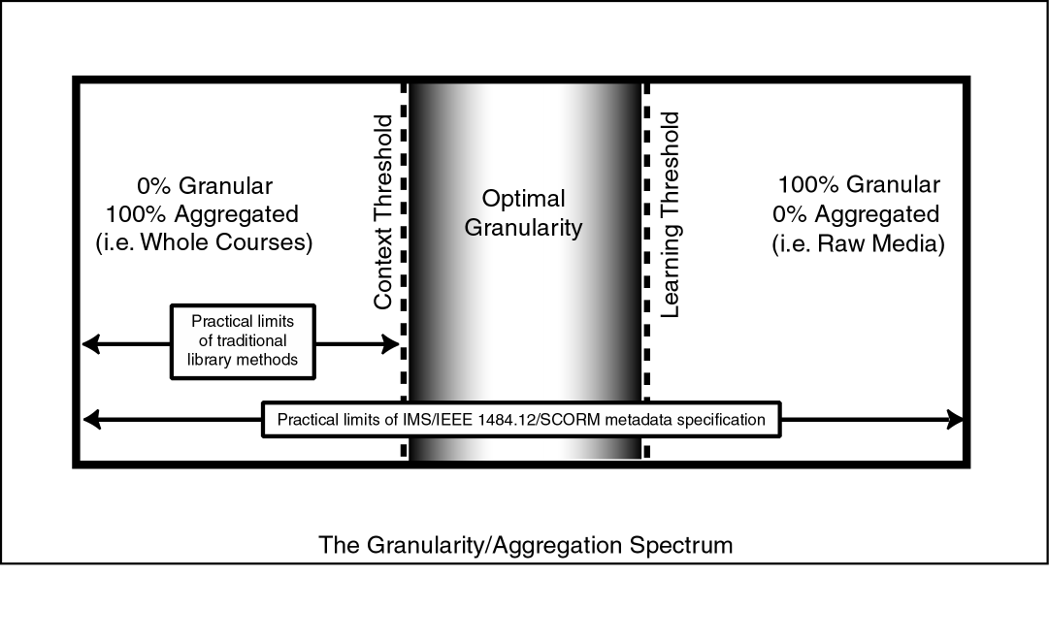
Figure 4. The Granularity/Aggregation Spectrum showing the limits of traditional library methods and that of the IMS/IEEE/SCORM metadata standards.
In librarian terms, creating metadata for learning objects is the equivalent of cataloging not just a book but also all of its chapters, photographs, charts, diagrams, etc. Therefore, it becomes important to minimize the number of fields required for each object and, in general, streamline the entire process of gathering metadata. We have decided that MARC records should be reserved for collections of objects. These MARC records serve as pointers from the standard library catalog into specialized learning object repositories. Within the learning object repositories, we rely on IMS metadata standards to identify the individual objects.
Many developers tend to wait to create metadata until after a learning object has been created. However, it has been our experience that it is more time consuming and laborious to create metadata after an object is developed than to create the metadata in parallel with the object. Our approach utilizes the windows of opportunity where various fields can be most efficiently captured. For example, the design specification for a new learning object provided by the subject matter expert and the instructional designer will in most cases include a title and description—with a little persuasion and a good performance support tool these fields and possibly others such as subject headings can be efficiently captured into a metadata record. This makes the final review of the data a relatively easily managed process.

Set Development Priorities
In order to insure that university resources designated for instructional media development have the greatest possible impact, we use a central planning committee to set development priorities.
The highest priority for university funds is high enrolling, bottleneck courses, usually general education (G.E.) courses. These courses receive the largest amount of allocated funds proportionately. This allows us to create and offer high quality, hybrid versions of these courses that are designed to require less time in the classroom. For instance, one G.E. science course now meets once a week rather than three times a week. This helps free up seat space, allowing more sections to be taught. An additional benefit is that, because these courses tend to be those of a basic, general nature, we find that learning objects created for these courses are often quite useful, not only in existing classroom versions of the courses, but in several other 100 level and 200 level courses. In other words, we find that the reusability of objects created for these courses is particularly high.
The second priority for university funds is medium-sized courses where the kinds of innovations proposed in these courses could have widespread impact. These projects are generally funded with smaller grants, and their content is generally less reusable, though it is still useful to other courses. The most beneficial aspect of these projects is the emphasis on exploring new approaches to instructional media development that may carry a slightly higher risk of failure than those we are using to develop the larger, general education courses, but that show long-term promise. As a result, these smaller projects produce high-quality objects while serving a research and development function as well.
The third priority for university funds is converting libraries of existing physical media into digital media where practical. Where materials are clear of copyright issues, we convert them for digital delivery to classrooms and for use in courses. Our School of Religion is presently digitizing thousands of slides of Jerusalem and other religious sites. These slides will be used in many religion courses, but are also in demand for courses in political science, geography, range science, history, and sociology. Ultimately, we anticipate that large online commercial libraries of these kinds of images will exist, and this somewhat tedious conversion process will no longer be necessary.
The fourth priority for university funds is the individual professor who is innovating by themselves or with some graduate students to improve a course that may impact only a few students a year. In these cases, we provide the development tools, and, equally importantly, technical standards so that the media that they produce will be compatible with the media being produced for the larger, higher priority courses. This allows the faculty running these projects the freedom to create what they wish, but also helps insure that that their product will be in a format that allows it to be used by others at the university.
The combined effect of these initiatives is that 1) many highly reusable objects are created; 2) bottleneck courses where impact is greatest and potential reusability of objects is high are addressed first; 3) medium-sized courses experiment with instructional methods that may become useful for high enrolling classes; 4) libraries of media become available to the entire campus community; and 5) individual innovators have freedom to explore while still contributing useful objects to a common digital library.

The Payoff

Lower Costs
As expected, the initial expenditure on this system has been higher than for previous technologies. However, we expect long-term financial benefits. These potentially include:
- Lower Development Costs. We expect that wide-spread use of instructional design learning object templates will speed development and allow non-experts to created fairly sophisticated media that can be used both in the classroom and online.
- Lower Delivery Costs. Once the digital delivery system and the digital library are fully in place, we anticipate that we will save money by eliminating the overhead of a large human delivery organization and maintaining a large amount of media delivery equipment. We also hope to lower our maintenance cost of the media itself, since it will no longer wear out with repeated use.
- More Reuse. We expect a significant percentage of the learning objects that we are creating to be reused in many contexts. By having a large library available, we hope to reduce the cost of duplicate media considerably.

Higher Quality
We are already receiving very positive responses from instructors and learners using the objects designed by professionals in instruction and media design. We anticipate that the use of learning object development templates will amplify these gains over time.

More Participation
By publishing standards, making development tools available, and promoting an object approach to developing, we expect to see much more participation on the part of the faculty. Many more faculty are interested in producing a few objects for their classes than are interested in a full-blown development project. By taking the object approach, we have essentially lowered the time commitment bar for faculty to participate in media development.

More Collaboration
We believe that as departments see the potential of the digital library, they will band together to leverage the use of resources common to all of them. We have already seen grassroots initiatives in this area, where faculty eagerly contribute their materials, knowing that they will have access to the materials of others in the department and eliminating their need to maintain a personal media library.

Possible Cost Recovery
Because of the high quality of several of our objects, we are attracting the attention of textbook publishers, e-learning companies, and individuals at other universities who are interested in licensing our content for their use. If this were done on a large enough scale, we believe that an open market for learning objects could provide significant revenues over time. Future partnerships may also allow us to use the large libraries of non-interactive media owned by major book publishers as source material for our objects, greatly speeding production while reducing acquisition and copyright costs.

Conclusion
Without learning objects at the center of the design, most of the problems we are trying to address would remain relatively unaffected, even if the other changes to the system described above were made. For example, migrating to a fully digital delivery system or setting development priorities, while significant steps, only address part of the need and do little to address cost effectiveness. Even though we are clearly still in the formative phase of our implementation, we are gratified to see that instructors are already reusing objects in their individual classrooms that were originally developed for online courses and vice versa. From a practical standpoint, this marks the beginning of the kind of reuse that, if prevalent, will signal the success of the system or, if absent, the failure. To reach this point, extraordinary coordination and cooperation by disparate university entities has been required. While difficult at times, we have discovered that as we overcome traditional barriers between academic entities and service organizations, we discover new efficiencies that invigorate the entire institution. As more academic publishers and institutions of learning commit to a similar model and make their objects publicly available for reuse, we anticipate these efficiencies will grow exponentially. By that time, we hope to have progressed to the point where using and reusing digital learning objects is as typical a part of on- and off-campus academic life as opening a textbook. And that simply opening a textbook can no longer be considered typical.

Acknowledgements

The ongoing work of the Digital Learning Environments Research and Development Group (dle.byu.edu) at Brigham Young University, of which we are both members, contributed greatly to the conceptual basis of our present system.
References
Wiley, D. A. (2000). Connecting learning objects to instructional design theory: A definition, a metaphor, and a taxonomy. In D. A. Wiley (Ed.), The instructional use of learning objects. Bloomington, IN: Association for Educational Communications and Technology.
Wiley, D. A., South, J. B., Bassett, J., Nelson, L. M., Seawright, L. L., Peterson, T., & Monson, D. W. (1999). Three common properties of efficient online instructional support systems. The ALN Magazine, 3(2), [On-line]. Available: http://www.aln.org/alnweb/magazine/Vol3_issue2/wiley.htm

